Artificial Intelligence: Honours 2005

Agent Design

By Daniel Cabral 909703080

Table of Contents
Table of Contents 2
1a. Background 4
1b. PEAS Description 5
Performance Measure 5
Environment 5
Actuators 5
Sensors 5
1c. Task Environment 6
Partially Observable 6
Stochastic 6
Sequential 6
Dynamic 6
Continuous 6
Multi-Agent 6
2. Classification of Agent 7
Model-based, Goal-based Agent 7
3. Use Cases 8
User 8
Environment 8
Agent 8
4. Packages 10
5. Functional Requirements 11
Start Simulation 11
Pause Simulation 11
Continue Simulation 11
Stop Simulation 11
View Simulation Statistics 12
New Environment 12
Edit Environment 12
Select Environment 13
Delete Environment 13
Generate Environment 13
New Agent 14
Edit Agent 14
Select Agent 14
Delete Agent 14
View Agent Knowledge Base 15
Open Window 15
Change Weather 15
Find Next Window 16
Recharge Battery/ Refill Water 16
Return to Bay 17
Move 17
Clean 17
Detect Window 18
Detect Obstacle, Edge 18
Detect Other Agent 18
Load State 19
Save State 19
6. Class Diagram 20
7. Interaction Sequence Diagrams 21
Start Simulation 21
New Environment 21
Generate Environment 22
New Agent 22
Find Next Window 23
Return to Bay 24
Clean 24
8. Intelligence of Agent 25
Online Search 25
Offline Search 25
MultiAgent Planning 26
9. References 27

1a. Background

The business of cleaning windows on building facades using manual labour has some disadvantages:
- It is slow, time-consuming and costly.
- Human lives are unnecessarily placed in danger.
- Platforms and suspension cables are an inconvenience.

As buildings become larger more windows are required and the problems are compounded. Therefore I propose a solution whereby an autonomous window-cleaning agent can be utilized for the semi-mechanical activity if window cleaning. It will provide the following benefits:
- Cleaning is more efficient, less time-consuming.
- No risk of loosing human life.
- Completely autonomous. (Of course technicians would be needed for services and supplies)
- No more suspension cables and platforms.

1b. PEAS Description

Performance Measure
The number of clean windows every hour. 1 cost value for each action taken.

Environment
- Building facades. The façade is represented as a grid. A block in the grid can contain a window, obstacle, agent or nothing.
- A window has a dirt level of 0 to 10. If the dirt level is 0 then the window is clean.
- Bay on top of building. This is the initial location of agent. Bay is a docking compartment built specially to provide water and power supply for the agent. The bay is the starting point above block [0, 0] of the grid.
- Weather conditions. Eg. Rain.
- Obstacles. Eg. Ventilators.
- Other agents.

Actuators
- The agent can move UP, DOWN, LEFT or RIGHT.
- Moving has no effect if there is an obstacle in front of the agent.
- The action CLEAN can be used to clean a window. If the dirt level is 5 then it will take 5 CLEAN actions to clean the window,

Sensors
- Bay sensor. To detect if agent is in the bay.
- Window sensor.
- Open Window sensor.
- Dirt sensor.
- Obstacle sensor.
- Building edge sensor.
- Agent sensor. To detect other agents on the façade.
- Environmental sensor.

1c. Task Environment

Partially Observable
Agent only has local dirt sensors, therefore it cannot tell whether there is dirt on other windows. On an unexplored façade the agent does not know the locations of the windows.

Stochastic
The next state of the environment is not completely determined by the agent’s actions. Eg. It could rain all of a sudden or someone might open a window,

Sequential
The agent must remember which windows it has already cleaned.

Dynamic
The environment can change while the agent is deliberation. Eg. Weather changes, someone opens a window, dirt accumulates at a variable rate, other agent cleaning windows at the same time.

Continuous
Continuous time and state problem. State of windows changes over time as well as location of agents,

Multi-Agent
Cooperative multi-agent environment can occur for large building facades. The performance measure is maximized by avoiding duplicate work.

2. Classification of Agent

Model-based, Goal-based Agent

A simple reflex agent would not be appropriate as the environment is partially observable. Therefore a model-based approach would be correct because internal state would be needed for information such as:
- Which windows were cleaned.
- Location of agent relative to the bay.
- Location of other agents.

Furthermore a goal-based approach should be included to help the agent decide what to do and what action sequence to take. Decision making is different from “condition-action rules” as it involves consideration of the future. Eg. What will happen when I move to the next window? Will I have enough battery power to move to the window? If the answer is no the goal of the agent will change from “FIND NEXT WINDOW” to “RECHARGE BATTERY”. In this case the agent would have to use the correct action sequence (shortest path) to get back to the bay to recharge its battery.

3. Use Cases
[Fowler, UML Distilled 3rd Edition Pg.99 – 105]

User
- Start Simulation
- Pause Simulation
- Continue Simulation
- Stop Simulation
- View Simulation Statistics
- New Environment
- Edit Environment
- Generate Environment
- Select Environment
- Delete Environment
- New Agent
- Edit Agent
- Select Agent
- Delete Agent
- View Agent Knowledge Base

Environment
- Change Weather
- Open Window

Agent
- Move
- Save State
- Load State
- Clean
- Detect Window
- Detect Obstacle/Edge
- Recharge Batter/ Refill Water
- Find Next Window
- Return to Bay
- Detect other Agent

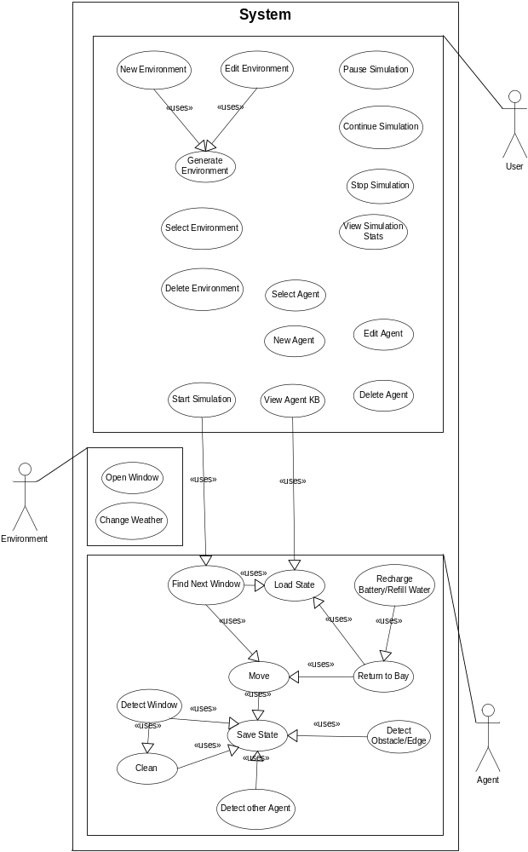

4. Packages
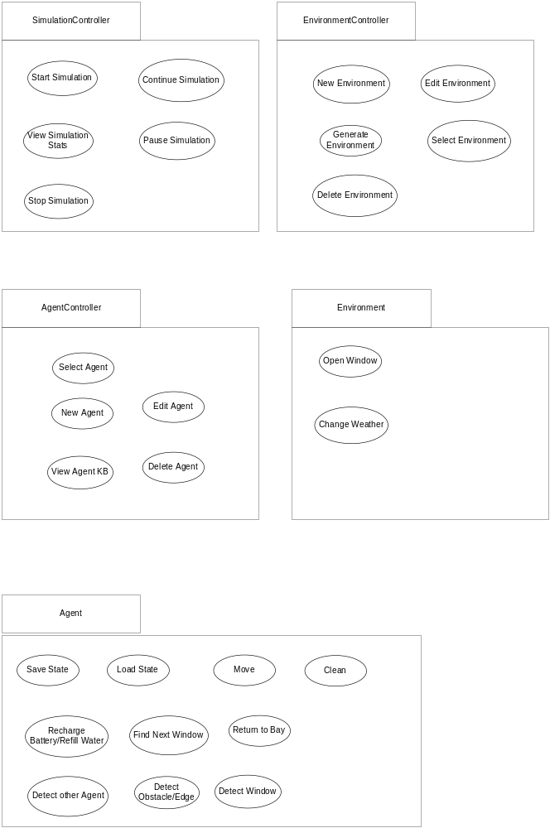

5. Functional Requirements

Start Simulation

Main Success Scenario
- User selects an Environment.
- User selects an Agent.
- User starts simulation.
- Agent placed in bay on top of building.
- Agent tries finds next window.

Extensions
2a: User selects another agent, returns to MSS (Main Success Scenario) at step 3.

Pause Simulation

Main Success Scenario
- Simulation is busy running.
- User elects to pause the simulation.
- The agent and environment pause and no activity takes place.

Continue Simulation

Main Success Scenario
- Simulation is paused.
- User elects to continue simulation.
- The agent and environment continue where they left off.

Stop Simulation

Main Success Scenario
- Simulation is running or paused.
- User elects to stop simulation.
- All agent and environment activities halt and return to original state.

View Simulation Statistics

Main Success Scenario
- When the agent has completed its goal of cleaning the windows, the simulation is complete.
- User can then view the simulation statistics which can have the following information:
  - Performance Measure: At what rate were the windows cleaned? Number of windows cleaned per hour.
  - Duration of simulation.

Extensions
1a: The agent may also view the current statistics while simulation is in paused or running state.

New Environment

Main Success Scenario

- User elects to create new environment.
- User fills in environment information:
- Building width, height, and name.
- Number of windows.
- Layout of windows (uniform or scattered)
- Number of obstacles.
- Number of open windows (before and during simulation)
- Weather (overcast or clear)
- Dirt level of building (low, medium, high)
- User generates environment.
- User views generated environment.
- System saves environment.

Edit Environment

Main Success Scenario

- User selects an existing environment.
- User elects to edit environment.
- User changes the environment information.
- User generates changed environment.
- User views generated environment.
- System saves changed environment.

Select Environment

Main Success Scenario

- User views a list of existing environments.
- User selects the required environment for the current simulation.
- User views selected environment.

Delete Environment

Main Success Scenario

- User views a list of existing environments.
- User selects the environment for deletion.
- System deletes environment,

Generate Environment

Main Success Scenario

- User has filled in information for an environment.
- User elects to generate environment.
- The environment consists of the following:
- A building façade with a specified number of windows. Depending on the dirt level (low, medium, high) some windows are dirty (with dirt level ranging from 0 to 10) and some are clean.
- Some windows will be opened.
- The building façade will have the specified number of obstacles.
- The building façade will be overlaid with a 2-dimensional grid showing the position of the objects.
- The top-most-left block will be [0, 0] and just above it will be the bay. The bay will be the initial resting place of the agent.
- A block can contain a window, obstacle, agent or just the façade surface.
- [0, 0] contains no object, so that the agent is not boxed in.
- Windows can be arranged uniformly or can be scattered. In the uniform arrangement windows are placed in uniform rows and columns in a straight line. In the scattered arrangement windows are placed randomly on the building façade.
- System generated the environment and displays it to the user.
- User can elect to save environment or attempt another generation.

New Agent

Main Success Scenario

- User elects to create a new agent.
- User fills in agent information which consist of the following:
- Agent name.
- Selected algorithm for Offline Search (Breadth-first, Depth-first, Greedy best-first or A* search algorithms.) of already explored building facades.
- Selected algorithm for Online Search (Online Depth-first search or Learning real-time A* search) of unexplored building facades.
- System saves new agent.

Edit Agent

Main Success Scenario

- User views a list of existing agents.
- User selects the agent to edit.
- User changes agent information.
- System saves agent changes.

Select Agent

Main Success Scenario

- User views a list of existing agents.
- User selects agent from list.
- System displays agent information to user.

Delete Agent

Main Success Scenario

- User views a list of existing agents.
- User selects agent to delete.
- System prompts user for confirmation.
- User confirms.
- System deletes agent from repository.

View Agent Knowledge Base

Main Success Scenario

- User views a list of agents.
- User selects an agent.
- User elects to view agent’s knowledge base.
- User views a list of building facades the agent has explored and work on.
- User selects a building facade.
- System displays the internal representation of building façade to user.
- User views the following:
- The actions and percepts the agent has saved when exploring the facade.
- All the explored blocks of the building façade are highlighted.

Extensions

6a: System warns the user that the building façade has changed; therefore the knowledge base information is obsolete. The obsolete information is deleted and the agent must re-explore the changed building façade.

Open Window

Main Success Scenario

- While simulation is running, environment opens a window.
- Any agents cleaning the window will initiate the STOP action and try to “Find Next Window”.

Change Weather

Main Success Scenario

- While simulation is running, environment changes weather conditions at a random time.
- Depending severity of the weather the window’s dirt level increases.
- Agent goal changes to “Return to Bay”.
- When agent returns to bay, severe weather conditions subside.
- Agent can now resume finding and cleaning windows based on what has already been explored.

Find Next Window

Main Success Scenario

- User has finished setting up an environment and selected agent.
- User elects to start simulation.
- User informs the agent of the number of windows to clean and on what building façade it will work on.
- The agent has not explored the environment yet so it uses an Online-search algorithm for exploration.
- Its first goal is to “Find Next Window”. So it initiates the “MOVE” action to proceed to initial block [0, 0].
- It will MOVE based on its current search algorithm.

Extensions

4a: The agent has explored this environment. Therefore is uses an Offline-search algorithm to find the solution for cleaning all the windows.

Recharge Battery/ Refill Water

Main Success Scenario

- Before agent initiates next action it reviews its internal state.
- Every action decreases battery power by 1. Every CLEAN action decreases water supply by 1.
- If next action would cause the agent not to be able to have enough power to get back to the bay the agent would not initiate that action. Instead it will change its goal to “Return to Bay”.
- If the agent’s water supply is empty it will change its goal to “Return to Bay”.
- Once agent has reached the bay, battery power and water supply become full.

Return to Bay

Main Success Scenario

- Agent’s goal changes to “Return to Bay” when windows are finished being cleaned, battery power is low or weather conditions change.
- Agent uses its Offline-search algorithm to find the best route to take.
- Once agent has reached the bay, battery power and water supply become full.
- If windows are all finished being cleaned simulation stops.

Extension

4a: If windows are not all finished being cleaned the agent would start cleaning windows again.

Move

Main Success Scenario

- Agent uses Online-search algorithm to decide which is the best move to make.
- Agent initiates MOVE action and tries to go UP, DOWN, LEFT or RIGHT.
- Agent in new location.
- Agent saves state after action is complete. The state will consist of current location, action and any percepts.

Extensions

3a: Agent detects closed window. It them initiates the CLEAN action.
3b: Agent detects obstacle or edge and either backtracks or tries a different MOVE action.

Clean

Main Success Scenario

- Agent detects a window in a certain location.
- Window’s dirt level is > 0.
- Agent initiates CLEAN action.
- Window’s dirt level is decremented by 1.
- Agent’s battery power is decremented by 1.
- Agent’s water supply is decremented by 1.
- Agent saves state.
- Agent initiates CLEAN action until dirt level is 0.
- After window is cleaned, goal changes to “Find Next Window”.

Extensions

9a: If it is the last window to be cleaned goal changes to “Return to Bay”.

Detect Window

Main Success Scenario

- Agent attempts to MOVE in a certain direction.
- Agent detects a window in the block it want to move to.
- Agent stops MOVE action and processes window, dirt percept.
- Agent initiates CLEAN action.
- Agent saves state.

Detect Obstacle, Edge

Main Success Scenario

- Agent attempts to MOVE in a certain direction.
- Agent detects an obstacle or edge of building.
- Agent stops MOVE action.
- Agent saves state.
- Agent stays in same location and decides which next MOVE action to take based on its current algorithm.

Detect Other Agent

Main Success Scenario

- Agent detects other agent on building façade.
- Agent retrieves other agent’s data regarding current simulation.
- This data consists of actions, percepts of agent.
- Together the agents create a joint plan consisting of actions for each agent.
- Agent then executes it actions as part of the joint plan.

Load State

Main Success Scenario

- User elects to start simulation.
- Agent has already explored the environment. It loads state data.
- Agent uses state data to search for the best solution for cleaning all the windows, maximizing the performance measure.
- State data consists of actions, percepts, locations and environment state changes from previous explorations.

Extensions

1a: Agent elects to “Return to Bay”. Continues with step 2 of MSS.

Save State

Main Success Scenario

- Agent has completed an action.
- Agent detects current state of environment based on percepts it receives.
- Agent saves current state of environment resulting from action.

6. Class Diagram
[Fowler , UML Distilled 3rd Edition, Pg 65 – 84]

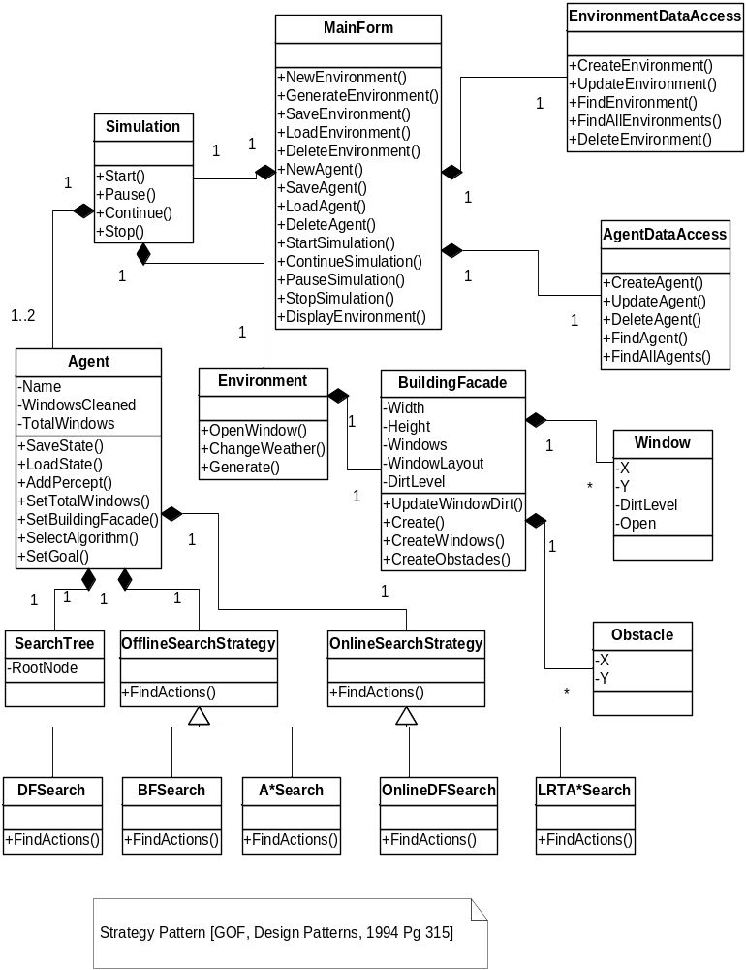

7. Interaction Sequence Diagrams

Start Simulation

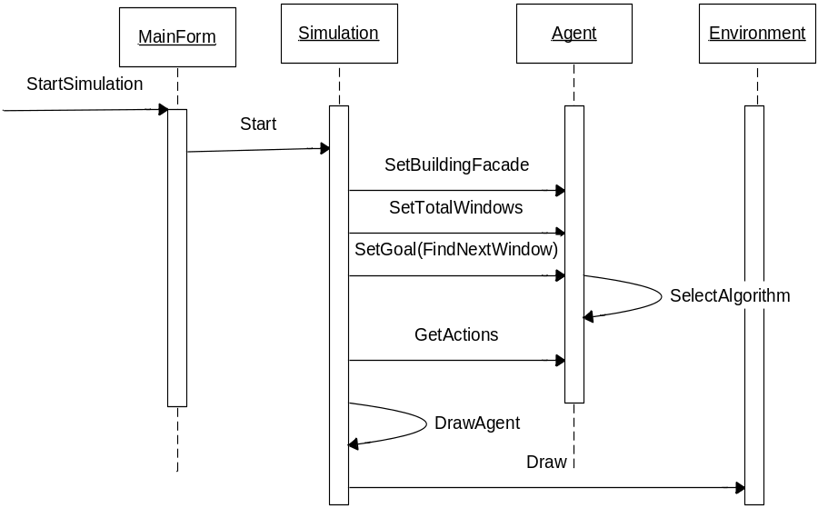

New Environment

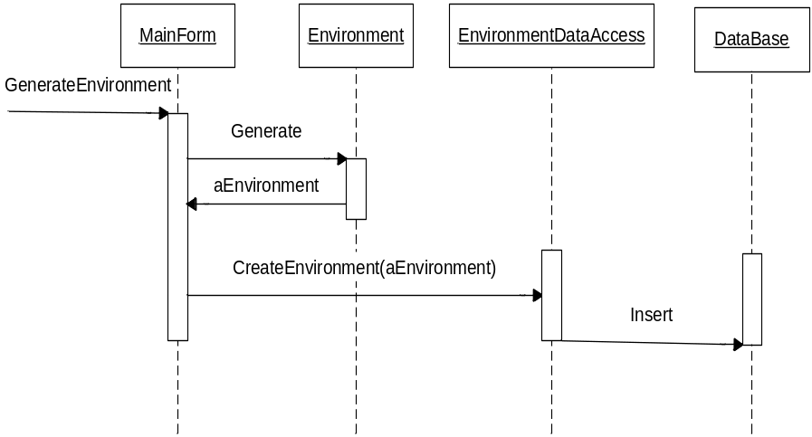

Generate Environment

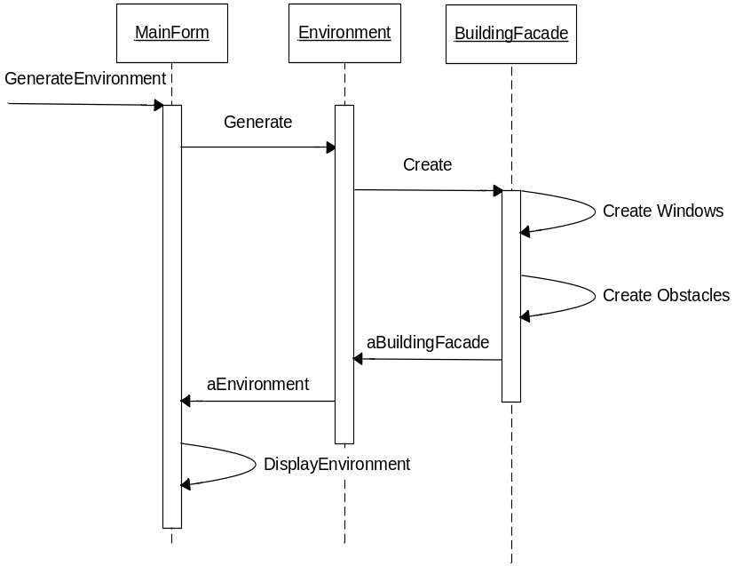

New Agent

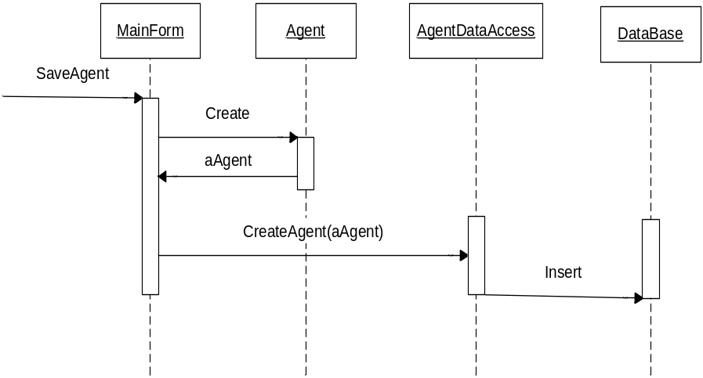
Change Weather

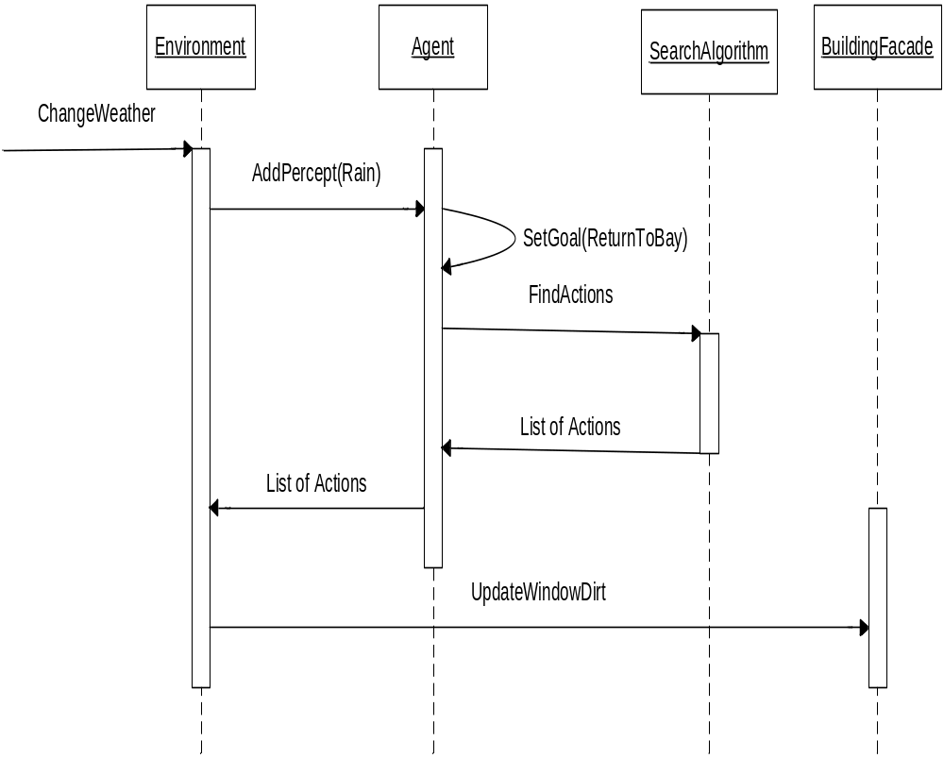

Find Next Window
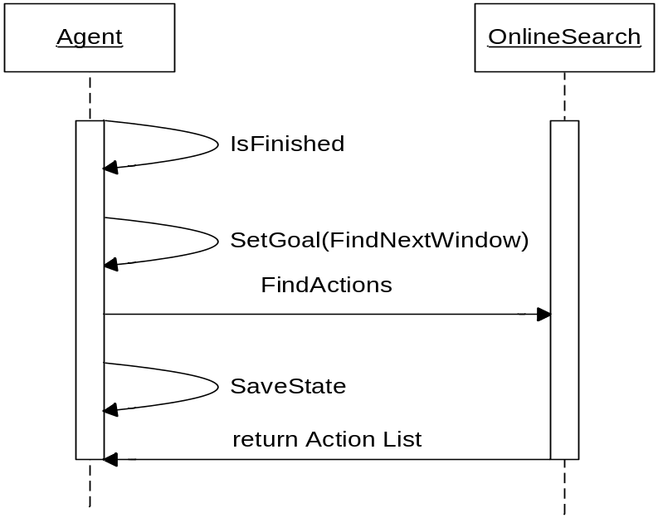

Return to Bay

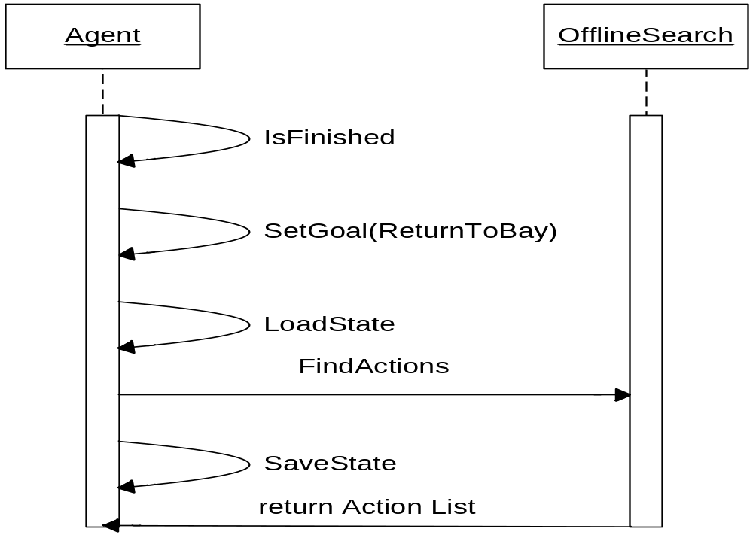

Clean

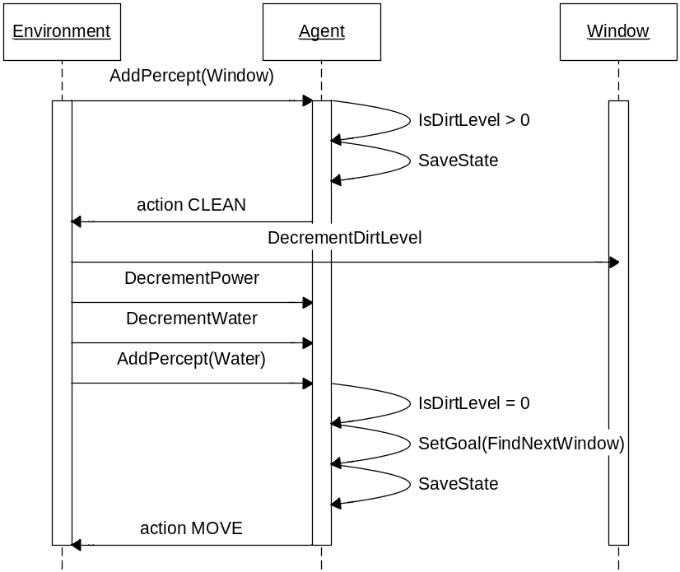

8. Intelligence of Agent

Online Search

[ Russel,.. AI A Modern Approach , Pg 122-129]

Initially when the agent is placed on a new building façade the only information it has is how many windows need to be cleaned. The agent has no knowledge of the location of windows and obstacles on the building façade. This is an example of an exploration problem.

Online search operates by interleaving computation and action: first it takes an action, then it observes the environment and computes the next action. The agent could utilize the following algorithms:
- Online-DFS (Depth-first search)
- Learning real-time A* (LRTA*)

With both algorithms the state resulting from executing actions in a specific state is stored. With LRTA* the next best move according to current cost estimates is chosen. This makes it more efficient than Online-DFS and decreases the competitive ratio (cost of exploration path of online agent compared with the actual shortest complete exploration).

Offline Search
[ Russel,.. AI A Modern Approach , Ch3-Ch4]

After the agent has explored its environment it now has enough information to conduct offline searches for computing solutions. The complete solution is found before the agent starts acting in its environment.

The agent could utilize the following algorithms:
- Depth-first search
- Breadth-first search
- Greedy best-first search.
- A* search.

The agent would conduct an offline search when it needs to return to its bay or when it needs to clean windows for an explored building façade that has not changed.

MultiAgent Planning
[ Russel,.. AI A Modern Approach Pg 449 – Pg451]

There can be at most 2 agents on a building façade. This multiagent environment will be cooperative. The agents would have the joint goal of cleaning all the windows in the shortest time possible.

The solution would be a joint plan consisting of actions for each agent. And added complexity is the fact that the 2 agents would have different knowledge bases of the explored/unexplored building façade. Since agents can detect each other they may use their combine information of the environment to formulate the optimum solution. 2 agents working together would provide 2 advantages:
- Their combined information of the environment can be used for the best solution (classic example of synergy).
- Since there are 2 agents obviously the windows would be cleaned in a shorter time.

9. References

- Fowler : UML Distilled 3rd Edition
- Gamma, Helm, Johnson, Vlissides : Design Patterns
- Russel, Norvig : Artificial Intelligence a Modern Approach.
- http://www.skybot.com

